**Line Chart**

## Simple Line Chart

We choose one dimension and one measure to create a simple line chart. Let’s drag the dimension Ship Mode to Columns Shelf and Sales to the rows shelf. Choose the Line chart from the Marks card. We get the below line chart which shows the variation of Sales for different Ship modes.

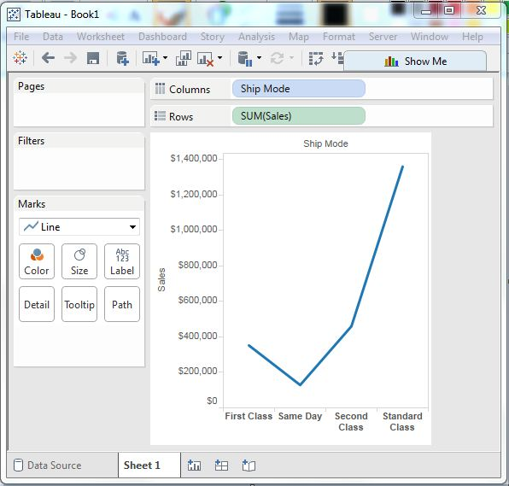

## Multiple Measure Line Chart

We can use one dimension with two or more measures in a line chart. This will produce multiple line charts each in one pane. Each pane represents the variation of the dimension with the one of the measures.

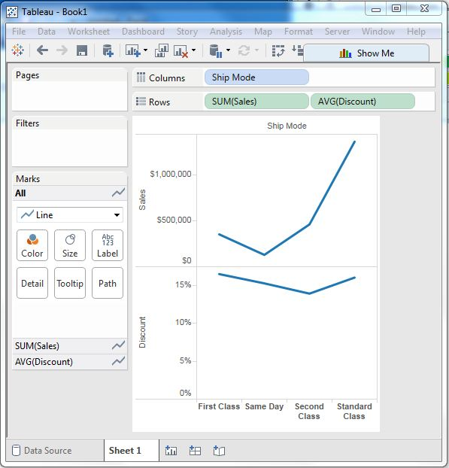

## Line Chart with Label

Each of the points making the line chart can be labeled to make the values of the measure visible. In this case let's drop another measure Profit Ratio into the labels pane in the Marks card. Choose average as the aggregation and we get the below chart showing the labels.

